EXERCISE – 10 (RANDOM FOREST)
1. AIM
To build and evaluate a Random Forest classifier for heart disease prediction, including ROC-AUC analysis.
2. ALGORITHM
1. Load and inspect the dataset.
2. Check the structure, data types, missing values and target distribution.
3. Separate the features from the target Heart Disease.
4. Prepare the preprocessing for the numerical and categorical features.
5. Create a RandomForestClassifier with 100 trees and random_state = 42.
6. Split the data, train the model and generate predictions.
7. Calculate the training and testing accuracy, precision, recall and F1 score.
8. Plot the ROC curve and calculate the ROC-AUC score.
3. PROGRAM
# Import required libraries
import pandas as pd
import numpy as np
import matplotlib.pyplot as plt
import seaborn as sns
# Machine Learning libraries
from sklearn.model_selection import train_test_split
from sklearn.compose import ColumnTransformer
from sklearn.preprocessing import OneHotEncoder
from sklearn.pipeline import Pipeline
from sklearn.ensemble import RandomForestClassifier
# Evaluation metrics
from sklearn.metrics import (
accuracy_score,
precision_score,
recall_score,
f1_score,
classification_report,
confusion_matrix,
ConfusionMatrixDisplay,
roc_curve,
roc_auc_score
)
# Load the dataset
df = pd.read_csv("heart_disease_dataset.csv")
# Display first 5 rows
df.head()
# Display number of rows and columns
print("Dataset Shape:", df.shape)
# Display column names
print(df.columns)
# Display data types
df.info()
# Check missing values
print(df.isnull().sum())
# Check target class distribution
print(df["Heart Disease"].value_counts())
# X contains input features
# y contains the target variable
X = df.drop("Heart Disease", axis=1)
y = df["Heart Disease"]
print("Features Shape:", X.shape)
print("Target Shape:", y.shape)
# Identify numerical columns
numerical_features = X.select_dtypes(
include=["int64", "float64"]
).columns
# Identify categorical columns
categorical_features = X.select_dtypes(
include=["object"]
).columns
print("Numerical Features:")
print(list(numerical_features))
print("\nCategorical Features:")
print(list(categorical_features))
# Preprocessing for numerical and categorical features
preprocessor = ColumnTransformer(
transformers=[
("num", "passthrough", numerical_features),
("cat", OneHotEncoder(handle_unknown="ignore"),
categorical_features)
]
)
# Create Random Forest classifier
rf_model = RandomForestClassifier(
n_estimators=100,
criterion="gini",
max_depth=None,
min_samples_split=2,
min_samples_leaf=1,
max_features="sqrt",
random_state=42,
n_jobs=-1
)
# Combine preprocessing and Random Forest model
model = Pipeline(
steps=[
("preprocessor", preprocessor),
("classifier", rf_model)
]
)
# Split dataset into training and testing sets
X_train, X_test, y_train, y_test = train_test_split(
X,
y,
test_size=0.2,
random_state=42,
stratify=y
)
print("Training Data:", X_train.shape)
print("Testing Data:", X_test.shape)
# Train the model
model.fit(X_train, y_train)
print("Random Forest Model Trained Successfully!")
# Predict on training data
y_train_pred = model.predict(X_train)
# Predict on testing data
y_test_pred = model.predict(X_test)
print("Predictions Generated Successfully!")
# Calculate evaluation metrics
train_accuracy = accuracy_score(y_train, y_train_pred)
test_accuracy = accuracy_score(y_test, y_test_pred)
precision = precision_score(y_test, y_test_pred)
recall = recall_score(y_test, y_test_pred)
f1 = f1_score(y_test, y_test_pred)
print("Training Accuracy :", round(train_accuracy, 4))
print("Testing Accuracy :", round(test_accuracy, 4))
print("Precision :", round(precision, 4))
print("Recall :", round(recall, 4))
print("F1 Score :", round(f1, 4))
# Predict probabilities
y_test_proba = model.predict_proba(X_test)[:, 1]
# Calculate ROC curve
fpr, tpr, thresholds = roc_curve(y_test, y_test_proba)
# Calculate AUC
auc_score = roc_auc_score(y_test, y_test_proba)
print("ROC-AUC Score:", round(auc_score, 4))
# Plot ROC Curve
plt.figure(figsize=(8, 6))
plt.plot(
fpr,
tpr,
label=f"Random Forest (AUC = {auc_score:.2f})"
)
plt.plot(
[0, 1],
[0, 1],
linestyle="--",
label="Random Classifier"
)
plt.xlabel("False Positive Rate")
plt.ylabel("True Positive Rate")
plt.title("ROC Curve - Random Forest")
plt.legend()
plt.show()

4. OUTPUT
The program was executed on the Heart disease dataset (heart_disease_dataset.csv) and produced the following output:
Age Gender ... Chest Pain Type Heart Disease
0 75 Female ... Atypical Angina 1
1 48 Male ... Typical Angina 0
2 53 Male ... Atypical Angina 1
3 69 Female ... Non-anginal Pain 0
4 62 Female ... Asymptomatic 0
[5 rows x 16 columns]
Dataset Shape: (1000, 16)
Index(['Age', 'Gender', 'Cholesterol', 'Blood Pressure', 'Heart Rate',
'Smoking', 'Alcohol Intake', 'Exercise Hours', 'Family History',
'Diabetes', 'Obesity', 'Stress Level', 'Blood Sugar',
'Exercise Induced Angina', 'Chest Pain Type', 'Heart Disease'],
dtype='object')
<class 'pandas.core.frame.DataFrame'>
RangeIndex: 1000 entries, 0 to 999
Data columns (total 16 columns):
# Column Non-Null Count Dtype
--- ------ -------------- -----
0 Age 1000 non-null int64
1 Gender 1000 non-null object
2 Cholesterol 1000 non-null int64
3 Blood Pressure 1000 non-null int64
4 Heart Rate 1000 non-null int64
5 Smoking 1000 non-null object
6 Alcohol Intake 660 non-null object
7 Exercise Hours 1000 non-null int64
8 Family History 1000 non-null object
9 Diabetes 1000 non-null object
10 Obesity 1000 non-null object
11 Stress Level 1000 non-null int64
12 Blood Sugar 1000 non-null int64
13 Exercise Induced Angina 1000 non-null object
14 Chest Pain Type 1000 non-null object
15 Heart Disease 1000 non-null int64
dtypes: int64(8), str(8)
memory usage: 125.1 KB
Age 0
Gender 0
Cholesterol 0
Blood Pressure 0
Heart Rate 0
Smoking 0
Alcohol Intake 340
Exercise Hours 0
Family History 0
Diabetes 0
Obesity 0
Stress Level 0
Blood Sugar 0
Exercise Induced Angina 0
Chest Pain Type 0
Heart Disease 0
dtype: int64
Heart Disease
0 608
1 392
Name: count, dtype: int64
Features Shape: (1000, 15)
Target Shape: (1000,)
Numerical Features:
['Age', 'Cholesterol', 'Blood Pressure', 'Heart Rate', 'Exercise Hours', 'Stress Level', 'Blood Sugar']
Categorical Features:
['Gender', 'Smoking', 'Alcohol Intake', 'Family History', 'Diabetes', 'Obesity', 'Exercise Induced Angina', 'Chest Pain Type']
Training Data: (800, 15)
Testing Data: (200, 15)
Random Forest Model Trained Successfully!
Predictions Generated Successfully!
Training Accuracy : 1.0
Testing Accuracy : 0.99
Precision : 1.0
Recall : 0.9744
F1 Score : 0.987
ROC-AUC Score: 1.0
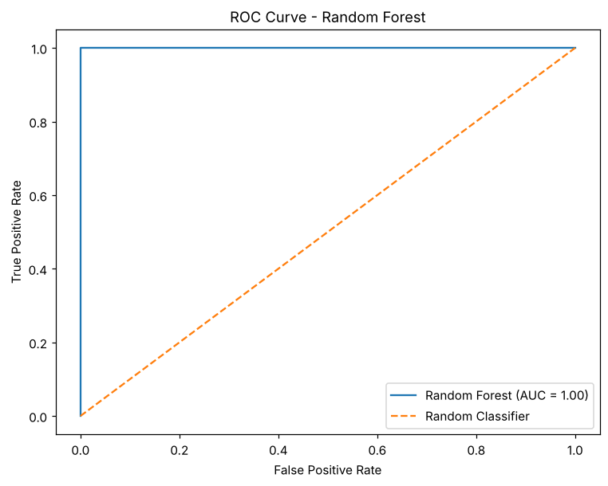

5. RESULT
Thus, the Random Forest practical was implemented successfully. The model obtained a training accuracy of 1.0 and a testing accuracy of 0.99, with a precision of 1.0, a recall of 0.9744, an F1 score of 0.987 and a ROC-AUC score of 1.0.

